SIMATS ENGINEERING
SAVEETHA INSTITUTE OF MEDICAL AND TECHNICAL SCIENCES

Department | AIML
Course Code / Course Name | DSA0601 / Data Handling and Visualization
Experiment | Data Visualization using R
Name | A Shiva Shankar Reddy
Register Number | 192425174
Date | October 1, 20262026
Day | Thursday

SET 5: WEBSITE ANALYTICS
Dataset: Website Traffic
List of Experiments Data Handling.pdf
Program 1: Line Chart – Daily Page Views
Question
Create a line chart to visualize the trend in daily page views over time. Label the axes and title the chart.
Aim
To create a line chart to visualize daily website page views over time.
R Code
R
# Create website traffic data
date <- c("2023-01-01", "2023-01-02", "2023-01-03",
"2023-01-04", "2023-01-05")

page_views <- c(1500, 1600, 1400, 1650, 1800)

# Draw line chart
plot(page_views,
type = "o",
col = "blue",
xlab = "Date",
ylab = "Page Views",
main = "Daily Website Page Views",
xaxt = "n")

# Add date labels
axis(1, at = 1:5, labels = date)
Output
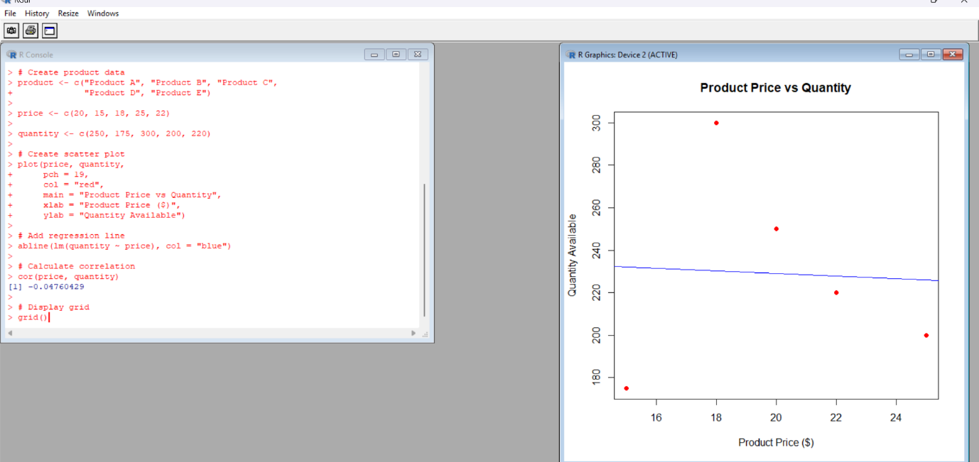
A line chart showing the daily page views from January 1 to January 5, 2023.
Result
The line chart was successfully created to visualize the trend in daily website page views.
Program 2: Bar Chart – Top N Days by Click-through Rate
Question
Generate a bar chart showing the top N days with the highest click-through rates. Label the chart elements.
Aim
To generate a bar chart displaying the days with the highest click-through rates.
R Code
R
# Create website traffic data
date <- c("Jan 01", "Jan 02", "Jan 03", "Jan 04", "Jan 05")

ctr <- c(2.3, 2.7, 2.0, 2.4, 2.6)

# Select top 3 days
top <- order(ctr, decreasing = TRUE)[1:3]

# Draw bar chart
barplot(ctr[top],
names.arg = date[top],
col = "green",
xlab = "Date",
ylab = "Click-through Rate (%)",
main = "Top 3 Days by Click-through Rate")
Output
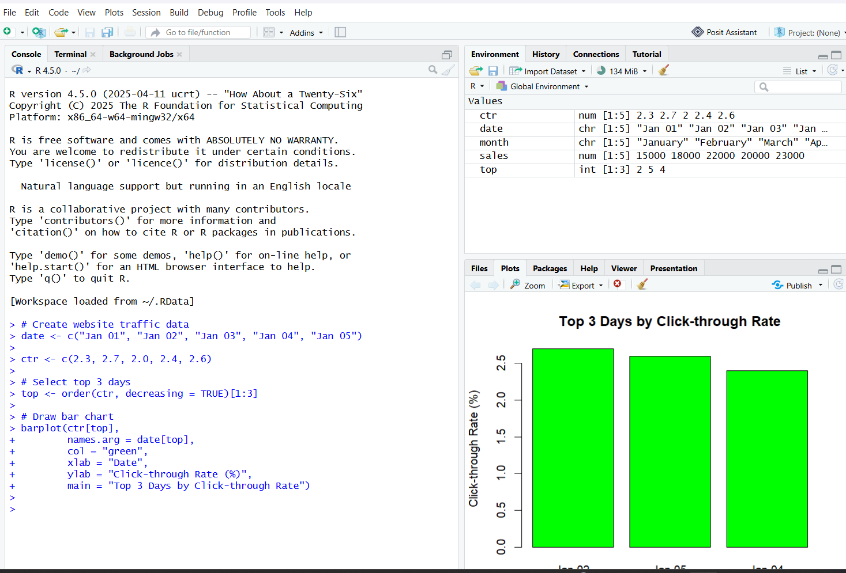
The bar chart displays:
- January 2 – 2.7%
- January 5 – 2.6%
- January 4 – 2.4%
Result
The bar chart was successfully generated to display the top three days based on click-through rate.
Program 3: Stacked Area Chart – User Interactions
Question
Develop a stacked area chart to display the distribution of user interactions (likes, shares, comments) on a website.
Aim
To create a stacked area chart representing likes, shares, and comments over time.
Note: The original dataset does not provide likes, shares, and comments values. The following values are illustrative data used to demonstrate the chart.
List of Experiments Data Handling.pdf
R Code
R
# Create illustrative interaction data
days <- 1:5

likes <- c(100, 120, 150, 180, 200)
shares <- c(40, 50, 60, 70, 80)
comments <- c(20, 30, 35, 40, 50)

# Combine data
data <- rbind(likes, shares, comments)

# Draw stacked area chart
area <- data

matplot(days, t(area),
type = "n",
xlab = "Days",
ylab = "Number of Interactions",
main = "Website User Interactions")

# Add stacked areas
polygon(c(days, rev(days)),
c(likes, rep(0, 5)),
col = "lightblue")

polygon(c(days, rev(days)),
c(likes + shares, rev(likes)),
col = "lightgreen")

polygon(c(days, rev(days)),
c(likes + shares + comments,
rev(likes + shares)),
col = "orange")

legend("topleft",
legend = c("Likes", "Shares", "Comments"),
fill = c("lightblue", "lightgreen", "orange"))
Output
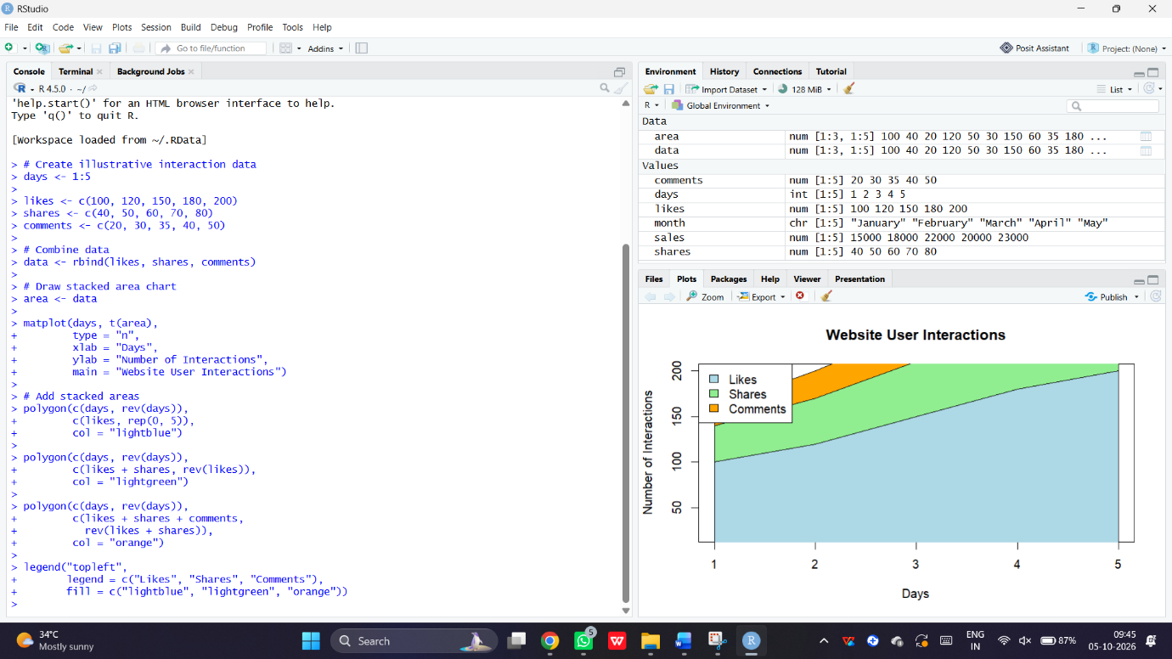
A stacked area chart displaying likes, shares, and comments across five days using illustrative values.
Result
The stacked area chart was successfully created to visualize the distribution of website user interactions.
Program 4: Interactive Website Traffic Dashboard
Question
Build a Tableau dashboard with the line chart and bar chart for interactive exploration of website traffic data.
Aim
To develop an interactive website traffic dashboard using R Shiny with a line chart and bar chart.
Note: This is an R Shiny equivalent for the dashboard requirement, not a Tableau dashboard.
R Code
R
# Install package if required
# install.packages("shiny")

library(shiny)

# Website traffic data
date <- c("Jan 01", "Jan 02", "Jan 03", "Jan 04", "Jan 05")

page_views <- c(1500, 1600, 1400, 1650, 1800)
ctr <- c(2.3, 2.7, 2.0, 2.4, 2.6)

data <- data.frame(date, page_views, ctr)

# User interface
ui <- fluidPage(
titlePanel("Website Traffic Dashboard"),

h3("Daily Page Views"),
plotOutput("line"),

h3("Click-through Rate"),
plotOutput("bar")
)

# Server
server <- function(input, output) {

output$line <- renderPlot({
plot(data$page_views,
type = "o",
col = "blue",
xlab = "Date",
ylab = "Page Views",
main = "Daily Page Views",
xaxt = "n")

axis(1, at = 1:5, labels = data$date)
})

output$bar <- renderPlot({
barplot(data$ctr,
names.arg = data$date,
col = "green",
xlab = "Date",
ylab = "CTR (%)",
main = "Click-through Rate")
})
}

# Run dashboard
shinyApp(ui = ui, server = server)
Output
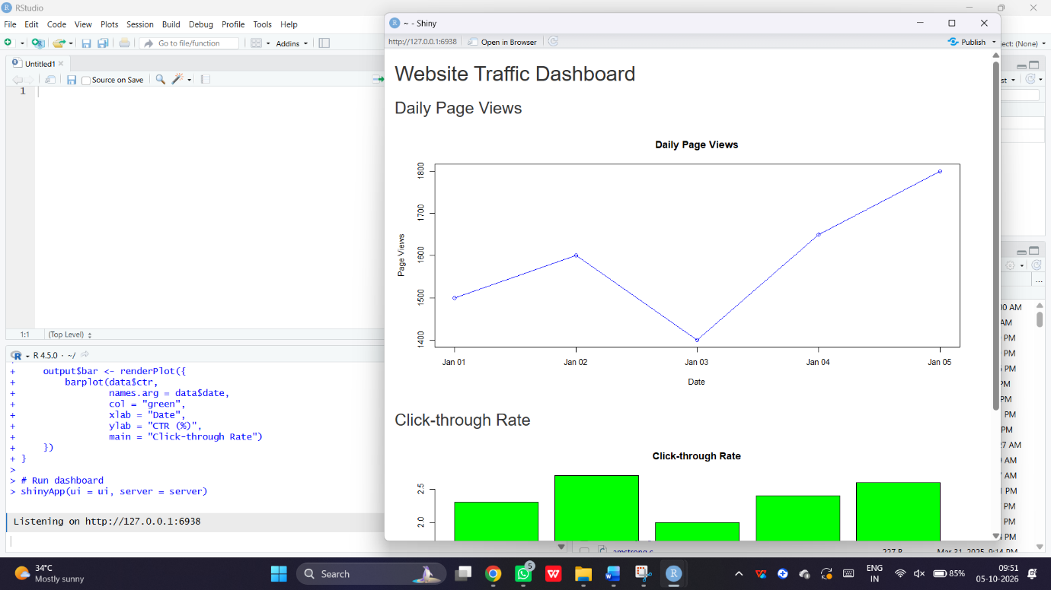
An interactive dashboard displaying:
- A line chart for daily page views.
- A bar chart for click-through rates.
Result
The website traffic dashboard was successfully developed using R Shiny for visual exploration of website traffic data.

